**Documentation – Practical work no. 4**

1.

|  |  |  |
| --- | --- | --- |
| Activity | Time | Prerequisites |
| 0 | 1 | - |
| 5 | 2 | - |
| 6 | 5 | 0, 5 |
| 4 | 1 | 5 |
| 1 | 2 | 6 |
| 3 | 2 | 4, 6 |
| 2 | 1 | 3, 6 |

TopoSort:

sortedGraph = []

fullyProcessed = {}

isProcess = {}

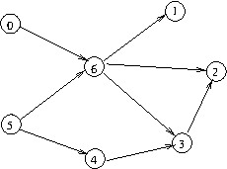

x = 0

sorted = [0]

fullyProcessed = {0}

x = 1

inProcess = {1}

y = 6

inProcess = {1, 6}

y = 0

y = 5

inProcess = {1, 6, 5}

sorted = [0, 5]

sorted = [0, 5, 6]

sorted = [0, 5, 6, 1]

fullyProcessed = {0, 1, 5, 6}

inProcess = {2}

y = 6

y = 3

inProcess = {2, 3}

y = 4

inProcess = {2, 3, 4}

sorted = [0, 5, 6, 1, 4]

sorted = [0, 5, 6, 1, 4, 3]

sorted = [0, 5, 6, 1, 4, 3, 2]

tm(X) = t*m(X) = 0

tm (0) = max {t*m (X)} = 0

t*m (0) = tm (0) + 1 = 1

tm(5) = max {t*m(X)} = 0

t*m(5) = tm(5) + 2 = 2

tm(6) = max{t*m(5), t*m(0)} = 2

t*m(6) = tm(6) + 5 = 7

tm(1) = max{t*m(6)} = 7

t*m(1) = tm(1) + 2 = 9

tm(4) = max{t*m(5)} = 2

t*m(4) = tm(4) + 1 = 3

tm(3) = max{t*m(6), t*m(4)} = 7

t*m(3) = tm(3) + 2 = 9

tm(2) = max {t*m(3), t*m(6)} = 9

t*m(2) = tm(2) + 1 = 10

tm(Y) = max{t*m(1), t*m(2)} = 10 = t*m(Y)

tM(Y) = t*M(Y) = t*m(Y) = tm(Y) = 10

t*M(2) =min{tM(Y)} = 10

tM(2) = t*M(2) – 1 = 9

t*M(3) = min{tM(2)} = 9

tM(3) = 9 – 2 = 7

t*M(4) = min{tM(3)} = 7

tM(4) = t*M(4) – 1 = 6

t*M(1) = min{tM(Y)} = 10

tM(1) = t*M(1) – 2 = 8

t*M(6) = min{tM(1), tM(2), tM(3)} = 7

tM(6) = t*M(6) – 5 = 2

t*M(5) = min{tM(6), tM(4)} = 2

tM(5) = t*M(5) – 2 = 0

t*M(0) = min{tM(6)} = 2

tM(0) = t*M(0) – 1 = 1

|  |  |  |
| --- | --- | --- |
| Earliest Starting Point | Vertex | Latest Starting Point |
| 0 | 0 | 1 |
| 7 | 1 | 8 |
| **9** | **2** | **9** |
| **7** | **3** | **7** |
| 2 | 4 | 6 |
| **0** | **5** | **0** |
| **2** | **6** | **2** |

Total time: tM(Y) = 10

Critical activities: 2, 3, 5, 6

2.

|  |  |  |
| --- | --- | --- |
| Activity | Time | Prerequisites |
| 0 | 2 | - |
| 1 | 5 | - |
| 2 | 3 | 0 |
| 3 | 3 | 0 |
| 4 | 2 | 2 |

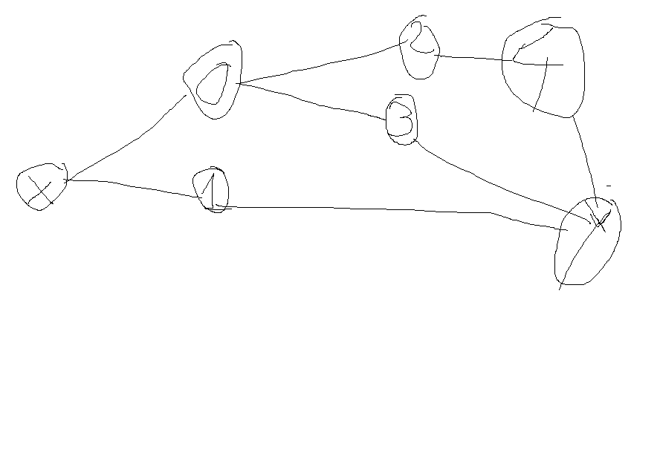

TopoSort:

sorted = []

fullyProcessed = {}

inProcess = {}

inProcess = {0}

sorted = [0]

inProcess = {1}

sorted = [0, 1]

inProcess = {2}

y = 0

sorted = [0, 1, 2]

inProcess = 3

y = 0

sorted = [0, 1, 2, 3]

inProcess = {4}

y = 2

sorted = [0, 1, 2, 3, 4]

tm(X) = t*m(X) = 0

tm(0) = max{t*m(X)} = 0

t*m(0) = tm(0) + 2 = 2

tm(1) = max{t*m(X)} = 0

t*m(1) = tm(1) + 5 = 5

tm(2) = max{t*m(0)} = 2

t*m(2) = tm(2) + 3 = 5

tm(3) = max {t*m(0)} = 2

t*m(3) = tm(3) + 3 = 5

tm(4) = max {t*m(2)} = 5

t*m(4) = tm(4) + 2 = 7

tm(Y) = max {t*m(1), t*m(3), t*m(4)} = 7 = t*m(Y)

tM(Y) = t*M(Y) = tm(Y) = t*m(Y) = 7

t*M(4) = min{tM(Y)} = 7

tM(4) = t*M(4) – 2 = 5

t*M(3) = min{tM(Y)} = 7

tM(3) = t*M(3) – 3 = 4

t*M(2) = min {tM(4)} = 5

tM(2) = t*M(2) – 3 = 2

t*M(1) = min{tM(Y)} = 7

tM(1) = t*M(1) – 5 = 2

t*M(0) = min{tM(2), tM(3)} = 2

tM(0) = t*M(0) – 2 = 0

|  |  |  |
| --- | --- | --- |
| Earliest Starting Point | Vertex | Latest Starting Point |
| **0** | **0** | **0** |
| 0 | 1 | 2 |
| **2** | **2** | **2** |
| 2 | 3 | 4 |
| **5** | **4** | **5** |

Total time: tM(Y) = 7

Critical activities: 0, 2, 4